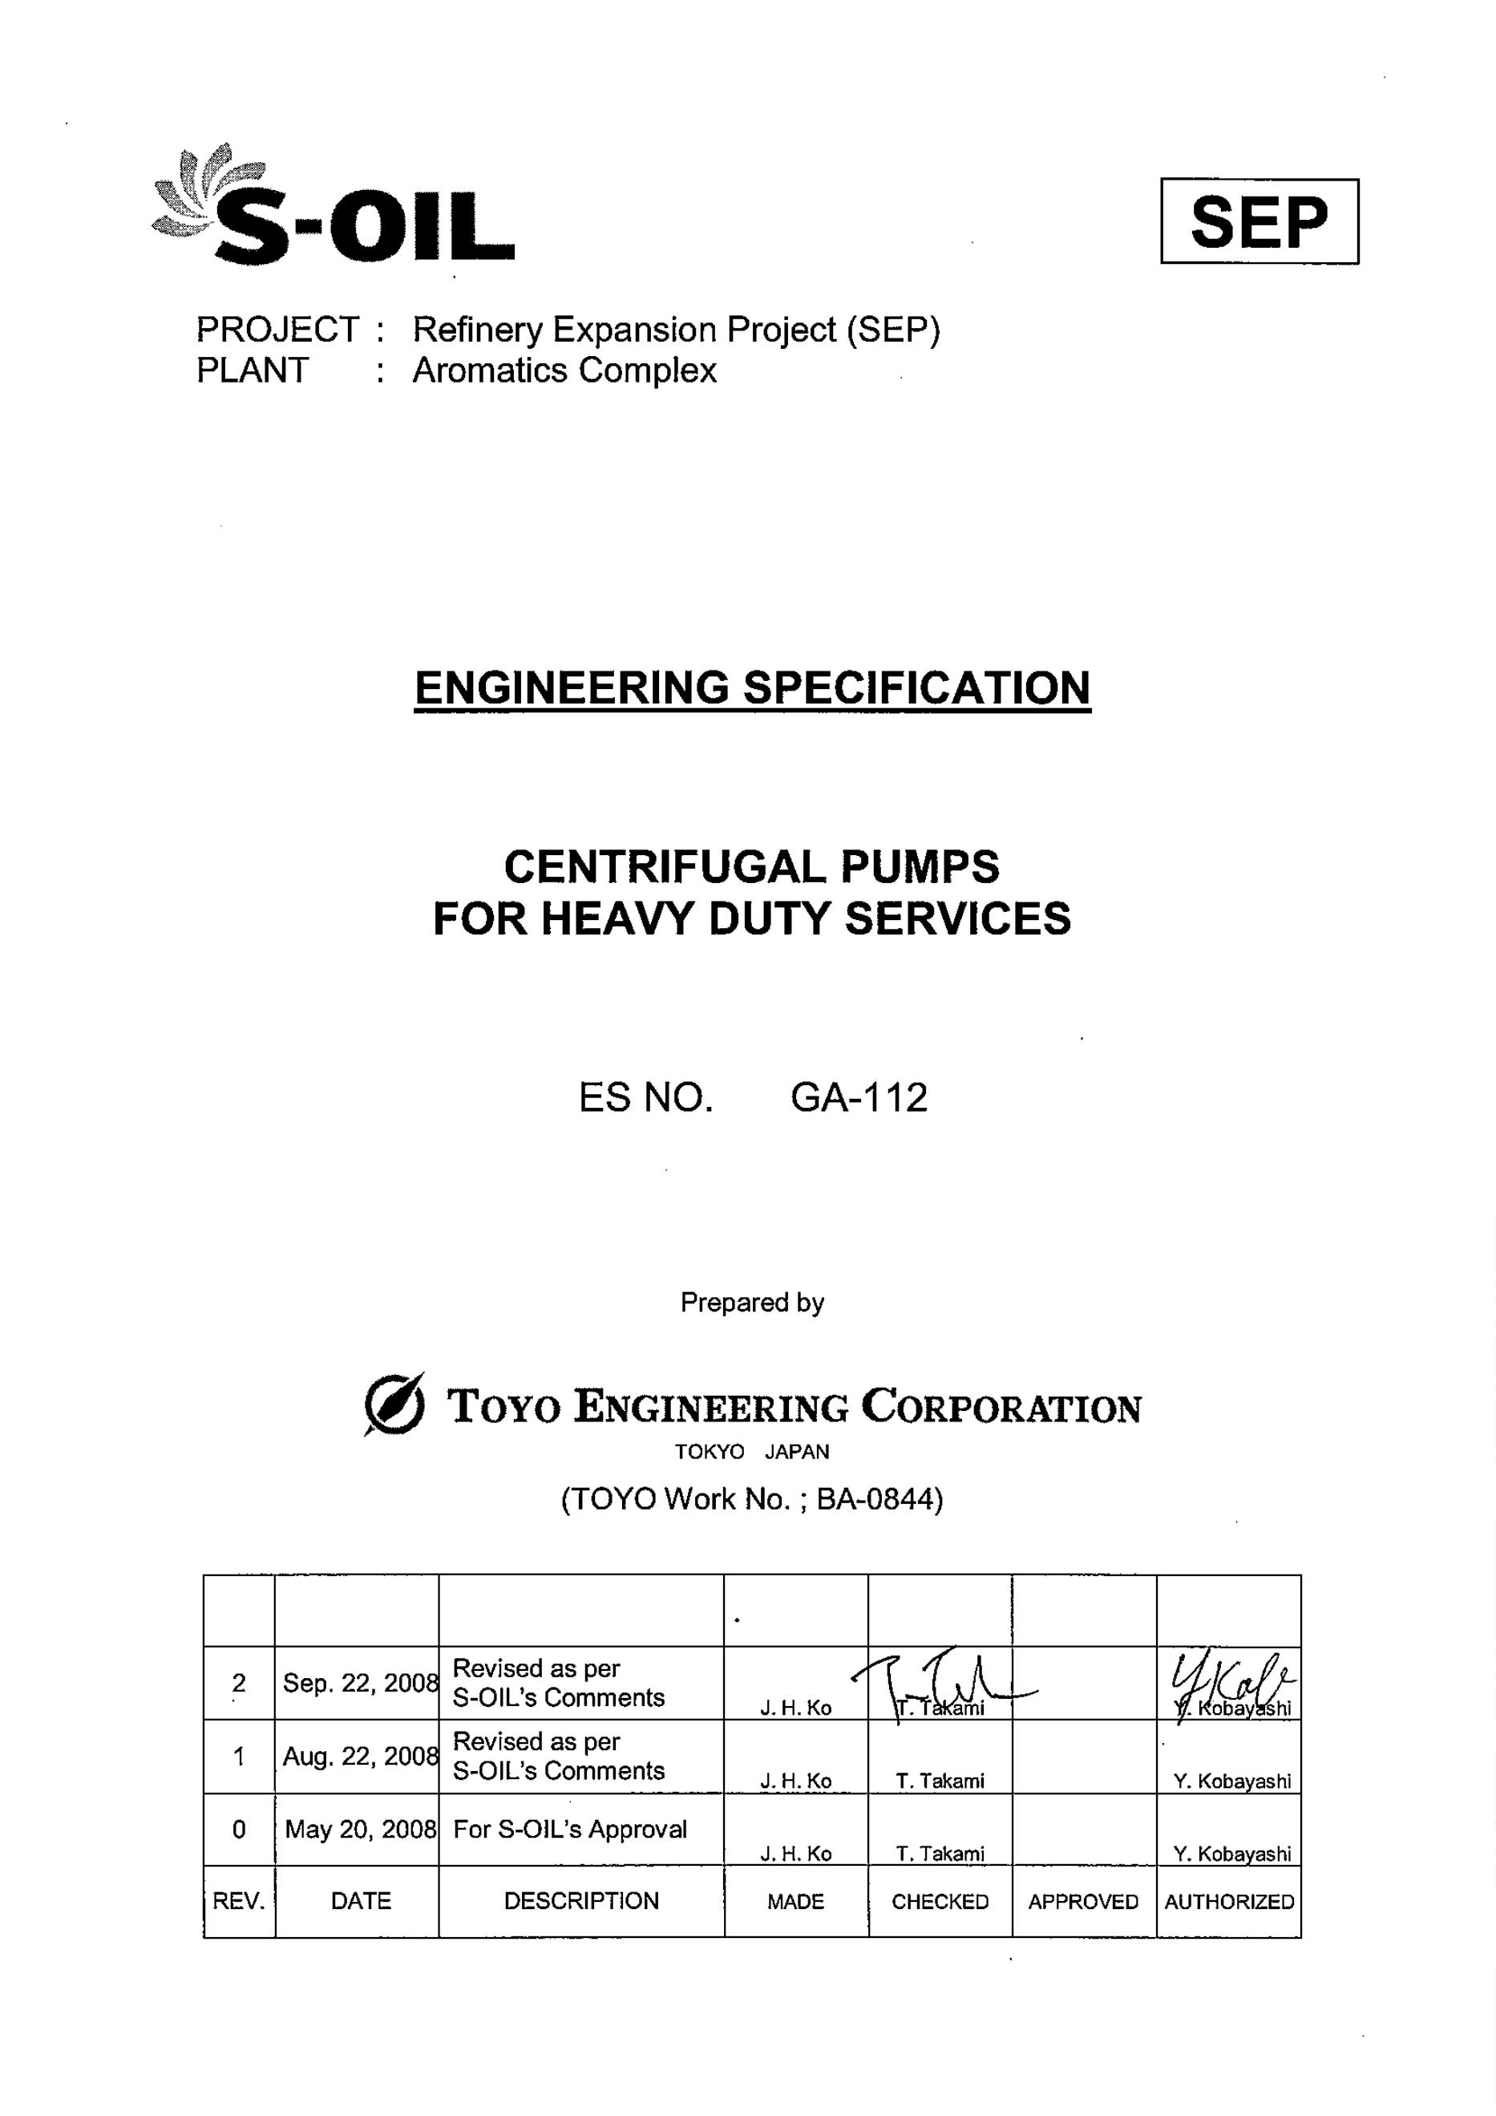

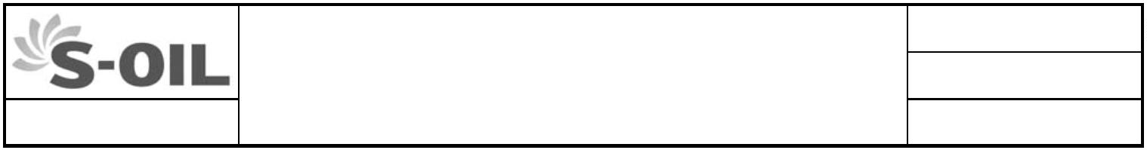
ES No.
ENGINEERING SPECIFICATION GA-112
 | Project ; SEP |  | Revision 2  CENTRIFUGAL PUMPS  FOR HEAVY DUTY SERVICES -
* REVISION HISTORY SHEET *
REV. NO. DATE DESCRIPTION
0 May 20, 2008 Newly Issued For S-OIL’s Approval
1 Aug. 22, 2008 Revised as per S-OIL’s Comments
2 Sep. 22, 2008 Revised as per S-OIL’s Comments
This document embodies proprietary information of Toyo Engineering Corporation and described thereon may not be copied or disclosed in any form or medium to third parties,
or used for other than the purpose for which it has been provided, in whole or in part in any manner except as expressly permitted.
BA-0844/GA-112_rev2.docGA-112_rev1.doc © TOYO ENGINEERING CORP.

ES No.
ENGINEERING SPECIFICATION GA-112
 | Project ; SEP |  | Revision 2  CENTRIFUGAL PUMPS  FOR HEAVY DUTY SERVICES -
CONTENTS
1. GENERAL...........................................................................................1
1.1 Scope.........................................................................................1
1.2 Codes and Standards ................................................................1
1.3 Data Sheets and Specifications.................................................2
1.4 Alternative Design......................................................................2
1.5 Measuring Units.........................................................................2
2. DESIGN ..............................................................................................2
2.1 General ......................................................................................2
2.2 Drivers and Gear Units ..........................................................545
2.3 Pressure Casings.......................................................................5
2.4 Materials ..................................................................................65
2.5 Nozzles and Miscellaneous Connections ..................................6
2.6 Auxiliary Piping and Equipment .................................................7
2.7 Impellers ....................................................................................7
2.8 Shaft and Shaft Sealing .............................................................8
2.9 Bearings and Bearing Housings ................................................9
2.10 Couplings and Guards .............................................................10
2.11 Mounting Plates .......................................................................10
2.12 Dynamics .................................................................................11
2.13 Pressure Lubrication System...............................................1211
2.14 Instrumentation ........................................................................12
2.15 Noise Level ..........................................................................1312
3. INSPECTION AND TESTS...............................................................13
4. PREPARATION FOR SHIPMENT....................................................13
4.1 General ....................................................................................13
4.2 Painting and Rust Prevention ..................................................13
4.3 Packing and Shipment.............................................................13
This document embodies proprietary information of Toyo Engineering Corporation and described thereon may not be copied or disclosed in any form or medium to third parties,
or used for other than the purpose for which it has been provided, in whole or in part in any manner except as expressly permitted.
BA-0844/GA-112_rev2.docGA-112_rev1.doc © TOYO ENGINEERING CORP.

ES No.
ENGINEERING SPECIFICATION GA-112
 | Project ; SEP |  | Revision 2  CENTRIFUGAL PUMPS  FOR HEAVY DUTY SERVICES -
CONTENTS
APPENDIX
A-I : Materials Class Selection Guide
A-II : Material Selection for Low Temperature Service
A-III : Material Class of Pump Parts
A-IV : Typical Application of Material Codes
B : Deleted
C-I : Detailed System of API Flushing Plan-52
C-II : Detailed System of API Flushing Plan-53
D : Typical Scheme of Pressurized Lube-Oil System (1/2, 2/2)
E : Materials Specification of Auxiliary piping for pumps (1/2, 2/2)
This document embodies proprietary information of Toyo Engineering Corporation and described thereon may not be copied or disclosed in any form or medium to third parties,
or used for other than the purpose for which it has been provided, in whole or in part in any manner except as expressly permitted.
BA-0844/GA-112_rev2.docGA-112_rev1.doc © TOYO ENGINEERING CORP.

ES No.
ENGINEERING SPECIFICATION GA-112
 | Project ; SEP |  | Revision 2  CENTRIFUGAL PUMPS  FOR HEAVY DUTY SERVICES PAGE 1 OF114
1. GENERAL
1.1 Scope
1.1.1 This specification together with the Requisition, Purchase Order/Inquiry and data
sheets covers the requirements to be met by Vendor in the design, fabrication,
inspection, testing and delivery conditions of heavy duty centrifugal pumps as
classified in the next paragraph. Pumps running in reverse as hydraulic power
recovery turbines shall also be included in this scope.
1.1.2 Applicable specifications for centrifugal pumps will be specified in each data sheet.
As general criteria, the centrifugal pumps for the following services shall be covered
by this specification:
(1) Flammable and hazardous service, unless otherwise specified.
(2) Non-flammable and non-hazardous service when its operating conditions
exceed any of the following limits:
Rated discharge pressure > 1.902 MPaG
Pumping temperature ≥ 150 °C
Rated speed (+5 % for turbine drives) > 3 600 rpm
Rated total head > 120 m
Maximum suction pressure > 0.5 MPaG
Maximum impeller diameter for overhung pumps > 330 mm
Maximum vapor pressure of pumped liquid > 0.172 MPaA
at maximum operating temperature
Sealless pumps of any operating conditions, regardless of the above (1) and (2),
shall be covered not by this specification but by another engineering specification.
1.2 Codes and Standards
1.2.1 Design, fabrication, inspection, testing and delivery conditions of the pumps covered
by this specification shall conform to the following API standards and those listed in
Engineering Specification G-101, except as modified hereinafter:
API 610 (10th edition) : Centrifugal Pumps for Petroleum, Petrochemical and
Natural Gas Industries
API 682 (3rd edition) : Pumps-Shaft Sealing Systems for Centrifugal and Rotary
Pumps
API 677 (3rd edition) : General-Purpose Gear Units for Petroleum, Chemical and
Gas Industries Services
The requirements in this engineering specification precede the relevant
requirements in the above API standards.
1.2.2 It shall be the responsibility of Vendor that all aspects of the design, fabrication,
inspection and testing conform to the requirements of the specified codes and
standards, and legal requirements.
This document embodies proprietary information of Toyo Engineering Corporation and described thereon may not be copied or disclosed in any form or medium to third parties,
or used for other than the purpose for which it has been provided, in whole or in part in any manner except as expressly permitted.
BA-0844/GA-112_rev2.docGA-112_rev1.doc © TOYO ENGINEERING CORP.

ES No.
ENGINEERING SPECIFICATION GA-112
 | Project ; SEP |  | Revision 2  CENTRIFUGAL PUMPS  FOR HEAVY DUTY SERVICES PAGE 2 OF214
1.2.3 Where there are conflicts between Purchaser’s data sheets/specifications and the
specified codes and standards or legal requirements, such conflicts shall be
promptly referred to Purchaser.
1.3 Data Sheets and Specifications
1.3.1 Purchaser will specify the requirements for each equipment on the data sheets in the
form of ISO 13709 (API 610) Standard for Centrifugal Pumps. The requirements
with a bullet (z) at the top of each paragraph in API Standards, will also be clarified in
the data sheets when necessary. The requirements in the data sheets precede
those in this engineering specification. Vendor shall develop the detailed data on his
responsibility based on the basic data given by Purchaser.
1.3.2 The related Engineering Specifications to supplement this specification are as
follows:
G-101 “Job Specification for Rotating Machines”
GA-202 “Inspection & Tests of Centrifugal Pumps”
Where there are conflicts between the specification G-101 and this specification, the
requirements included in G-101 shall govern.
1.3.3 Purchaser’s approval of such drawings and documents shall not relieve Vendor of his
responsibility to meet all requirements of the Purchase Order.
1.3.4 All drawings and documents shall give the name of Client (end user), Purchaser’s
work no., item no., and service name.
1.4 Alternative Design
Vendor may offer the alternative proposal which is favorable for every concerned
parties (Owner/Purchaser/and Vendor) from technical and commercial view points.
Purchaser will evaluate the alternative proposal, offered by Vendor, whether he
accepts it or not. The offering shall include detailed specification, reference
experience and standard criteria, if any.
1.5 Measuring Units
Unless otherwise specified, SI units shall be applied to the measurement system as
referred to Engineering Specification G-101.
2. DESIGN
2.1 General
2.1.1 The equipment covered by this specification shall be, as a design criterion, designed
and constructed for a minimum service life of 20 years (excluding normal wearing
parts such as mechanical seals, gland packings, shaft sleeves, gaskets and O-rings)
and at least 36 months of uninterrupted operation.
This document embodies proprietary information of Toyo Engineering Corporation and described thereon may not be copied or disclosed in any form or medium to third parties,
or used for other than the purpose for which it has been provided, in whole or in part in any manner except as expressly permitted.
BA-0844/GA-112_rev2.docGA-112_rev1.doc © TOYO ENGINEERING CORP.

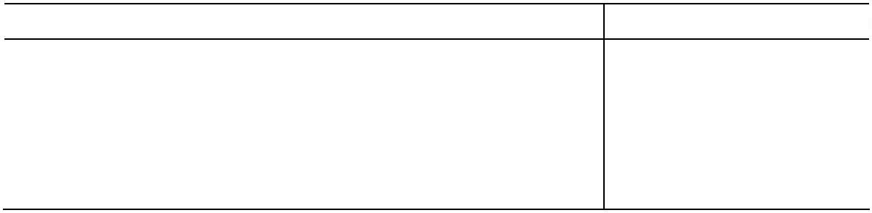
ES No.
ENGINEERING SPECIFICATION GA-112
 | Project ; SEP |  | Revision 2  CENTRIFUGAL PUMPS  FOR HEAVY DUTY SERVICES PAGE 3 OF314
2.1.2 All components shall have proven operating experience in similar duty to the
specified ones. Vendor shall check if the design includes any new factors on the
operating conditions, type, shape, dimensions, materials, and manufacturing.
Application of new design and unproven technology shall require Purchaser’s
approval before proceeding with manufacturing.
2.1.3 Pumps, auxiliaries and accessories shall be suitable for unsheltered outdoor
installation unless otherwise specified.
2.1.4 The normal operating point for the furnished impellers shall not be beyond the best
efficiency point. Vendor shall make his endeavor to select the pumps having the
best efficiency point nearest the normal point.
2.1.5 Vendor shall guarantee the pump performance to Purchaser in terms of capacity,
head, power consumption, NPSHR and efficiency at the specified rated conditions
with the tolerances specified in GA-202.
2.1.6 NPSHR is defined with correction to datum elevation as NPSH at 3 % head drop of
the 1st stage impeller head. NPSHR at rated point for horizontal pumps shall be
not more than NPSHA minus 0.6 m unless otherwise specified on the data sheet.
The datum elevation of the NPSH for horizontal pumps is the shaft centerline. For
vertical barrel pumps and vertical sump pumps, the NPSH margin shall be given at
the first stage impeller inlet. The margin for barrel inlet loss shall be at least 0.1 m
at the barrel inlet flange. In any case, no hydrocarbon correction shall be
appliedNPSHR is defined with correction to datum elevation as NPSH at 3 % head
drop of the 1st stage impeller head. NPSHR at rated point for horizontal and
horizontal pumps shall be not more than NPSHA minus 0.6 m unless otherwise
specified on the data sheet. The datum elevation of the NPSH is the shaft
centerline for horizontal pumps and the top of the foundation for vertical pumps
respectively. For vertical barrel pumps, the NPSH margin shall be given at the first
stage impeller inlet. The margin for barrel inlet loss shall be at least 0.1 m at the
barrel inlet flange. In any case, no hydrocarbon correction shall be applied..
2.1.7 Selection of the pumps which have a risk for recirculation problem under the
specified operating conditions shall be avoided. In this regard, the following criteria
as the maximum limits for the suction specific speed (S value in m³/min, rpm, m),
calculated at the best efficiency point with the maximum-diameter impeller, shall be
taken into the selection of the pumps. Vendor may offer other alternatives when he
has data enough to prove the reliability.
Service S
Small and medium capacity hydrocarbon service 1 900
Large capacity and low head hydrocarbon service 1 800
Small and medium capacity water service 1 700
Cooling tower water service 1 500 to 1 600
Others 1 700 to 1 900
Note : It is better to have a allowance of 100 for each value above.
The above requirements are valid for the pumps with no inducers. The
requirements for the pumps with a inducer shall be referred to the Par. 2.1.8.
2.1.8 When an inducer is provided, all the requirements stated below shall be satisfied.
This document embodies proprietary information of Toyo Engineering Corporation and described thereon may not be copied or disclosed in any form or medium to third parties,
or used for other than the purpose for which it has been provided, in whole or in part in any manner except as expressly permitted.
BA-0844/GA-112_rev2.docGA-112_rev1.doc © TOYO ENGINEERING CORP.

ES No.
ENGINEERING SPECIFICATION GA-112
 | Project ; SEP |  | Revision 2  CENTRIFUGAL PUMPS  FOR HEAVY DUTY SERVICES PAGE 4 OF414
(1) The S value shall be within the range of Vendor’s experience. However, the
suction specific speed lower than 3000 (m³/min, rpm, m) is preferable.
(2) The design capacity of the inducer shall be near to the rated point of the
pump.
(3) The inducer shall have stable mechanical performance on vibration, and shall
have high durability against erosion and any other mechanical failures.
(4) Stable operating range of the inducer shall be counted into the stable
minimum continuous flow which is specified in the data sheet.
2.1.9 Use of overhung type pump shall be avoided for the following case:
(1) Two stage pumps, unless otherwise specifically approved by Purchaser
(2) Double suction pumps
(3) Single stage pumps of large impeller diameters that exceed the proven
experience for overhung design
2.1.10 When a single volute casing is applied for the pumps with a discharge nozzle size of
4 inches or larger, it shall be subject to Purchaser’s approval. Vendor shall submit
to Purchaser the reference list showing its proven experience.
2.1.11 Horizontal mounted pumps are preferred. But vertical in-line pumps are also
acceptable when they are economically justified and within the range specified
below:
(1) Driver rated output up to 132 kW
(2) Impeller tip speed up to 50 m/s
(3) Pumping temperature up to 150 °C
2.1.12 Vertical in-line pumps shall be provided with a spacer coupling unless otherwise
specified.
2.1.13 Vertical in-line, integral-geared and high speed pumps (Sundyne Pumps) may be
used for services up to 260 kW. Pumps driven by a motor of 150 kW and greater in
its output rating, or of 1600 kg and heavier in weight shall be furnished with a motor
support of structural steel construction.
2.1.14 Vertical sump pumps shall be provided with a suction screen of proper mesh size by
Vendor.
2.1.15 For vertical pumps as well as horizontal pumps, the operating pressure specified on
the data sheet is the pressure at their nozzles unless otherwise specified.
2.1.16 All components shall have proven experience in similar duty to the specified one. No
prototype design and application shall be acceptable unless it is approved by
Purchaser. Selection of pumps shall be based on the following considerations:
- Standard product models
- Maximum interchangeability of parts
- Ease of maintenance and accessibility
2.1.17 Pump rated speed shall correspond to the rated speed of its driver.
This document embodies proprietary information of Toyo Engineering Corporation and described thereon may not be copied or disclosed in any form or medium to third parties,
or used for other than the purpose for which it has been provided, in whole or in part in any manner except as expressly permitted.
BA-0844/GA-112_rev2.docGA-112_rev1.doc © TOYO ENGINEERING CORP.

ES No.
ENGINEERING SPECIFICATION GA-112
 | Project ; SEP |  | Revision 2  CENTRIFUGAL PUMPS  FOR HEAVY DUTY SERVICES PAGE 5 OF514
2.1.18 If parallel operation is specified, the head rise from rated point to shutoff shall be at
least 10% for stable operation.
2.2 Drivers and Gear Units
2.2.1 Motor driver shall be designed for the end-of-the-curve for the rated impeller or as
specified in para. 6.1.3 of API 610, whichever is greater. However, an alternative
quotation for drivers in accordance with para. 6.1.3 of API 610 shall be submitted,
when end-of-the-curve horse power exceeds 150% of the pump rated brake horse
power.
2.2.2 Turbine drivers shall have output power ratings equal to at least 110% of brake
horsepower including all losses through power transmissions at pump rated point and
normal steam conditions.
2.2.3 Gear units shall be designed and constructed in accordance with API 677 or API 613
based on pump application.
2.2.4 Any power transmissions including the gear unit shall have the power rating at least
equal to the rated output power of the driver. For the power transmissions between
two driven equipment, all operating modes shall be examined and the rated power
shall be at least the rated output power of the driver proportioned to normal power
demands.
2.2.5 Pumps driven by variable speed drivers shall be designed to operate continuously at
any speed regulated by speed controllers, and to operate briefly, under emergency
condition, up to the trip speed.
2.3 Pressure Casings
2.3.1 Pumps, which will operate at temperature 0ºC and above, shall be designed for the
maximum anticipated operating temperature or specified operating temperature plus
15ºC, whichever is higher. Pumps, which will operate at temperatures below 0ºC,
shall be designed for the minimum operating temperature minus 5ºC or minimum
ambient temperature (-18ºC), whichever is lower.
2.3.2 Applicable types of casing split for boiler feed water pumps are as follows:
- Axially split type up to the rated discharge pressure of 9.807 MPaG
- Ring section type
- Barrel type
2.3.3 Axially split case shall not apply to the pumps, whose discharge pressure is 6.89
MPaG or higher, unless specifically approved by Purchaser.
2.3.4 Horizontal pumps shall be constructed to permit removal of rotating elements such
as impellers and shafts without disturbing the suction and discharge piping and/or
mounting of the pump casings unless otherwise specified.
This document embodies proprietary information of Toyo Engineering Corporation and described thereon may not be copied or disclosed in any form or medium to third parties,
or used for other than the purpose for which it has been provided, in whole or in part in any manner except as expressly permitted.
BA-0844/GA-112_rev2.docGA-112_rev1.doc © TOYO ENGINEERING CORP.


ES No.
ENGINEERING SPECIFICATION GA-112
 | Project ; SEP |  | Revision 2  CENTRIFUGAL PUMPS  FOR HEAVY DUTY SERVICES PAGE 6 OF614
2.4 Materials
2.4.1 Purchaser will specify the material class for casings and internals, as his basic
requirement, on the data sheet in accordance with the guideline as shown in
APPENDIX-A-I/-II/-III/-IV.
Vendor shall select the materials of each component based on the specified material
class as well as the specific operating conditions, and may use the equivalent
materials in accordance with any international standard including ISO, DIN, BSI,
AFNOR and JIS subject to Purchaser’s approval. Vendor shall be responsible for
the final material selection, except that Purchaser shall be responsible for the basic
classification.
2.4.2 For pumping temperatures below -29 °C, APPENDIX-A-II shall be referred to for the
material selection. The materials shall have an impact strength of not less than 20.6
N-m at the lowest operating temperature.
2.4.3 Details of casing corrosion allowances shall be as per Engineering Specification
G-101 unless otherwise specified.
2.4.4 Castings shall be sound and free of shrink and blow holes, scale, blisters and other
similar injurious casting defects. Cast iron shall not be repaired by welding without
specific approval of Purchaser.
2.4.5 No cast iron pressure parts shall be used for hydrocarbon service. Forged steel
barrel castings are preferred for high pressure services.
2.4.6 Pressure castings shall be of carbon steel or alloy steel in the form of castings,
forgings or pipes if pumps are to handle liquids under any of the following
conditions:
(1) Pumping temperature being 120 °C or higher
(2) Handling flammable or toxic liquids with vapor pressure greater than 0.098
MPaA measured at pumping temperature or at 40 °C, whichever is higher.
(3) Handling flammable or toxic liquids with specific gravity less than 0.825 at
pumping temperature and with design pressure exceeding 1.079 MPaG.
(4) Design pressure exceeding 1.765 MPaG, except for water service with the
temperature of 100 °C, or lower.
2.5 Nozzles and Miscellaneous Connections
2.5.1 The flow velocity at the suction nozzles and discharge nozzles shall be not higher
than the figures (in m/s) as follows:
 | Service At suction  nozzle |  | At discharge  nozzle
Hydrocarbon and Cold Water 7 14
Hot Water 5 10
Erosive or Corrosive Liquid 4 8
When the flow velocity at rated capacity exceeds the above figures, it shall be
This document embodies proprietary information of Toyo Engineering Corporation and described thereon may not be copied or disclosed in any form or medium to third parties,
or used for other than the purpose for which it has been provided, in whole or in part in any manner except as expressly permitted.
BA-0844/GA-112_rev2.docGA-112_rev1.doc © TOYO ENGINEERING CORP.

ES No.
ENGINEERING SPECIFICATION GA-112
 | Project ; SEP |  | Revision 2  CENTRIFUGAL PUMPS  FOR HEAVY DUTY SERVICES PAGE 7 OF714
subject to Purchaser’s approval.
2.5.2 Pump casings shall have flanged suction and discharge nozzles.
2.5.3 All pumps shall have suction flanges designed for the same pressure as discharge
flanges to permit testing under the required full test pressure.
2.5.4 Pumps shall be provided with a vent connection unless the pumps are made
self-venting by arrangement of nozzle. The pumps shall be furnished with auxiliary
connections for drain, shaft seal flushing, etc. as specified on the data sheets.
2.5.5 Pressure gauge connections shall not be provided on the pump casings unless
otherwise specified.
2.6 Auxiliary Piping and Equipment
2.6.1 Cooling water, vent, drain and other auxiliary piping systems including all
accessories such as gauges and valves shall be furnished fully assembled,
thoroughly cleaned, pressure-tested and installed neatly on the pump or within the
confines of baseplates.
2.6.2 Piping and equipment shall be designed and arranged for easy disassembling and
maintenance. Appropriate flanges connections shall be so arranged that the
pumps can be isolated with the stop valves furnished for a cooling water supply and
a return line and be disconnected from the cooling water network.
2.6.3 Copper or its alloys shall not be used for any components of auxiliary piping without
Purchaser’s approval.
2.6.4 Sight flow indicators of flapper or ball float type shall be furnished in each cooling
water outlet line.
2.6.5 The materials of the piping components shall be in accordance with APPENDIX-E.
Vendor may use the material in accordance with other international standard such
as DIN, JIS, etc. subject to Purchaser’s approval, when it corresponds to the
material specified above.
2.6.6 Socket welded fittings and flanges shall not be used for oil piping.
2.6.7 Orifice opening shall not be less than 1.5 mm in diameter.
2.6.8 Details of piping corrosion allowances shall be as per Engineering Specification
G-101 unless otherwise specified.
2.6.9 Cooling water manifold outlet valves shall be furnished by Vendor.
2.7 Impellers
2.7.1 Impeller diameter at rated condition shall not be greater than 90% of the max. size,
or one inch less than maximum, whichever results in larger size. Also the diameter
at the rated condition shall be at least one-forth inch larger than the min. size
impeller. Hydraulic turbines are an exception and may be designed utilizing max.
impeller/runner diameter.
This document embodies proprietary information of Toyo Engineering Corporation and described thereon may not be copied or disclosed in any form or medium to third parties,
or used for other than the purpose for which it has been provided, in whole or in part in any manner except as expressly permitted.
BA-0844/GA-112_rev2.docGA-112_rev1.doc © TOYO ENGINEERING CORP.


ES No.
ENGINEERING SPECIFICATION GA-112
 | Project ; SEP |  | Revision 2  CENTRIFUGAL PUMPS  FOR HEAVY DUTY SERVICES PAGE 8 OF814
2.7.2 When the tip velocity of the impeller exceeds the following figures, Vendor shall
submit such data as the design figures, materials and Vendor’s standard criteria for
Purchaser’s review:
Material Tip velocity (m/s)
Cast iron 35
Bronze 45
Ductile iron 50
304 or 316 stainless steel 65
Carbon steel 70
12 % Cr stainless steel 80
Note : When the driver of the pump is of variable speed, the tip velocity at the
maximum continuous speed shall be applied to the above criteria.
2.8 Shaft and Shaft Sealing
2.8.1 Unless otherwise specified, mechanical seals shall be provided for the shaft sealing,
and the seals and sealing systems shall be in accordance with API Standard 682.
The qualification tests specified in API Standard 682 will not be required as long as
proven types of seals are selected.
2.8.2 Seal-manufacturer shall be selected in accordance with Engineering Specification
G-101.
2.8.3 Basic requirements for the mechanical seals will be specified by Purchaser on the
data sheet of each pump.
Vendor shall specify his final selection on the data sheets, including API
classification codes, manufacturer’s codes, materials and auxiliary piping plans.
2.8.4 Shafts shall be made in one piece except for vertical pumps having a long shaft
subject to Purchaser’s approval, and shall be provided with sleeves securely locked
to the shaft.
2.8.5 Stuffing boxes with conventional packings shall be cooled by providing water jackets
around stuffing boxes or water injection into the gland if pumps are to operate at any
of the following conditions:
(1) Pump temperature being 80 °C or higher
(2) Suction pressure being 0.686 MPaG or higher
(3) Handling liquids with vapor pressure greater than 0.069 MPaA measured at
pumping temperature
Conventional packing shall not be used for process service.
2.8.6 Jackets or cooling inserts shall be provided on mechanical seal chamber for the
following conditions and services as a guide:
This document embodies proprietary information of Toyo Engineering Corporation and described thereon may not be copied or disclosed in any form or medium to third parties,
or used for other than the purpose for which it has been provided, in whole or in part in any manner except as expressly permitted.
BA-0844/GA-112_rev2.docGA-112_rev1.doc © TOYO ENGINEERING CORP.

ES No.
ENGINEERING SPECIFICATION GA-112
 | Project ; SEP |  | Revision 2  CENTRIFUGAL PUMPS  FOR HEAVY DUTY SERVICES PAGE 9 OF914
(1) Pumping temperature above 150 °C unless metal bellow type seals are used.
(2) Pumping temperature above 315 °C
(3) Boiler feed water pumps and water service whose temperature at seal face
exceeds 80 °C
(4) Dead-end seal arrangements
(5) Low-flash-point liquids
(6) High-melting-point products (heating)
2.8.7 Where suction pressure is vacuum, impellers shall be so arranged that stuffing box
pressure is positive. Otherwise, the stuffing box shall be effectively sealed to be
positive in pressure.
2.8.8 For conventional packings, lantern rings shall be used so that self-flushing can be
made. External flushing will be specified on the data sheets if necessary. Ample
space shall be provided for repacking without removing and dismantling any part
other than gland components and guards.
2.8.9 Where mechanical seals are used, flushing port shall be provided near the seal
surface so as to remove heat effectively from the seal.
2.8.10 The diameter of the portions of the shaft or shaft sleeves that are in contact with
mechanical seals shall be in increments of 10 mm. Minimum dimensions of seal
chambers shall conform to API Standard 682.
2.8.11 The mechanical seals and the gland shall not be used during the hydrostatic test.
2.8.12 The mechanical seals shall be mounted on the pumps before shop running tests
and shall not be dismantled after the successful shop test. Packings shall be
removed from the stuffing box for shipping after the shop test.
2.8.13 Shaft sleeves shall be sealed at one end. The end of the shaft-sleeve assembly (or
nut) shall extend beyond the outer face of the packing gland or beyond the seal end
plate so that any leakage between the shaft and the sleeve cannot become
confused with leakage through the stuffing box packing or the mechanical seal
faces.
2.8.14 For pumps handling hydrocarbons at temperature of 232 °C or higher, the
mechanical seal shall be of metal-bellows type.
2.8.15 For unpressurized dual mechanical seals, throttle bushing shall be provided.
2.8.16 When pressurized dual mechanical seals are specified, throttle bushings may not be
provided. The clearance of the throttle bushings shall conform to API Standard
610.
2.8.17 In case that seal flushing plan no. 52 or 53A is applied, a pressure switch or a level
switch for alarm shall be provided, and a cooling inserts shall be provided unless
otherwise specified. The scope of supply for the flushing plan 52 and 53A shall be
in accordance with APPENDIX-C-I and C-II.
2.9 Bearings and Bearing Housings
This document embodies proprietary information of Toyo Engineering Corporation and described thereon may not be copied or disclosed in any form or medium to third parties,
or used for other than the purpose for which it has been provided, in whole or in part in any manner except as expressly permitted.
BA-0844/GA-112_rev2.docGA-112_rev1.doc © TOYO ENGINEERING CORP.

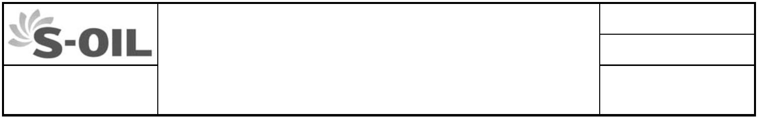
ES No.
ENGINEERING SPECIFICATION GA-112
 | Project ; SEP |  | Revision 2  CENTRIFUGAL PUMPS  FOR HEAVY DUTY SERVICES PAGE 10 OF  1014
2.9.1 Guide bushings for vertical pumps shall be made of Non-metal, unless otherwise
specified, and be suitable for the service and temperature.
2.9.2 When a lubrication system other than a forced system is applied to the sleeve
bearings of the peripheral speed higher than 15 m/s, it shall be subject to
Purchaser’s approval.
2.9.3 Bearing housings and brackets may be of steel for any services.
2.9.4 Bearing housings shall be effectively sealed against the invasion of water or dust.
2.9.5 Bearing lubrication system and cooling system shall be selected for the service
conditions, and shall be capable of operating continuously with the temperature at
any bearing housing below 71 °C for pressurized systems and below 82 °C for
flinger type based on the specified operating conditions and ambient temperature of
43 °C.
2.9.6 Bearing lubrication for sump type bearing housing shall be preferably done by
flinger, not by oil ring.
2.10 Couplings and Guards
2.10.1 Connections between horizontal pumps and drivers shall be made with
non-lubricated flexible disk (with corrosion-resistant membranes) couplings.
2.10.2 Spacer type couplings shall be furnished.
2.10.3 Removable coupling guards made of non-sparking materials shall be furnished by
Vendor.
2.10.4 A half coupling for driver shall be fully machined, and mounted on the driver in
general by a pump-vendor. When the pump-vendor is not required to mount the
driver, he shall deliver the fully machined a half coupling with the pump together with
the necessary instructions for mounting the half coupling on the driver shaft.
2.10.5 A limited end float coupling shall be provided when the drivers have no thrust
bearings.
2.11 Mounting Plates
2.11.1 For pumping temperature of 150ºC or higher, baseplates shall be designed to be
centerline supported casings for horizontal pumps. Pump supports of this type shall
be provided with supplemental cooling if required to maintain satisfactory alignment
or when pumping temperature is 260 °C or higher.
2.11.2 Baseplates shall be of welded steel structure and plate construction. Contact
surfaces shall be machined and bolt holes shall be bored in such a way that they
exactly fit the machine.
2.11.3 Grout holes and anchor bolt holes shall be provided on the baseplates. Surface of
baseplates shall be sloped so that drain can be collected at a drain port.
This document embodies proprietary information of Toyo Engineering Corporation and described thereon may not be copied or disclosed in any form or medium to third parties,
or used for other than the purpose for which it has been provided, in whole or in part in any manner except as expressly permitted.
BA-0844/GA-112_rev2.docGA-112_rev1.doc © TOYO ENGINEERING CORP.

ES No.
ENGINEERING SPECIFICATION GA-112
 | Project ; SEP |  | Revision 2  CENTRIFUGAL PUMPS  FOR HEAVY DUTY SERVICES PAGE 11 OF  1114
2.11.4 Baseplates shall have drain-rims or drain-pans which are sloped for the complete
drainage, where a tapped drain connection of 2 inch NPT shall be provided.
2.11.5 For vertical pumps, baseplates shall generally be of welded steel plate construction.
A minimum of four alignment position screws shall be provided for each drive train
component to facilitate horizontal alignment.
2.11.6 The pump and the driver shall be mounted on a common baseplate unless
otherwise specified.
2.11.7 Anchor bolts, nuts and all necessary inserts shall be furnished by Vendor.
2.11.8 Dimensions of baseplates may be in accordance with Vendor’s standards provided
that projection of the equipment supplied satisfies the requirement specified in the
next paragraph.
2.11.9 Projection of the equipment supplied shall fall within the maximum perimeter of the
baseplate. Exception to this requirement is acceptable for the following components:
- Junction boxes of electric motors
- Frame ends of the electric motors with grease lubricated bearings
2.11.10 When sizing the baseplates of vertically suspended double casing pumps for cold
service, the thickness of insulation materials around the barrel casings shall be
taken into account.
2.11.11 Driver-mounting frames of vertically suspended pumps shall be so designed that no
resonances shall occur within the range of operating speed. When specified in the
data sheet, Vendor shall demonstrate that the natural frequency of the mounting
frame does not coincide with the range of operating speed.
2.12 Dynamics
2.12.1 The first lateral critical speed of a stiff-shaft pump shall be at least 10% over the
maximum operating speed. When specified in the data sheets, the lateral critical
speed analysis report shall be submitted.
2.12.2 The first lateral critical speed of flexible shaft pump shall be not more than 60% of
the maximum operating speed and not closer than 15% to any operating speed. The
second critical speed shall be at least 20% over the maximum operating speed.
2.12.3 Vendor shall perform a lateral critical speed analysis and a damped unbalanced
response analysis for multistage pumps (three stages or more) with a flexible rotor
as defined in API Standard 610.
2.12.4 When specified on the data sheet, Vendor shall perform a torsional vibration
analysis of the complete coupled train and shall be responsible for directing the
proper modifications.
2.12.5 Each major component of the rotors shall be dynamically balanced to grade G 2.5 of
ISO 1940.
This document embodies proprietary information of Toyo Engineering Corporation and described thereon may not be copied or disclosed in any form or medium to third parties,
or used for other than the purpose for which it has been provided, in whole or in part in any manner except as expressly permitted.
BA-0844/GA-112_rev2.docGA-112_rev1.doc © TOYO ENGINEERING CORP.

ES No.
ENGINEERING SPECIFICATION GA-112
 | Project ; SEP |  | Revision 2  CENTRIFUGAL PUMPS  FOR HEAVY DUTY SERVICES PAGE 12 OF  1214
2.13 Pressure Lubrication System
2.13.1 A pressure lubrication system shall be furnished by the pump vendor if specified by
Purchaser or if recommended by Vendor. A typical scheme of oil lubrication
system is attached as APPENDIX-D.
2.13.2 As a minimum, the pressure lubrication system shall consist of :
(1) A shaft-driven main oil pump with a suction strainer.
(2) An auxiliary oil pump driven by an electric motor which is automatically cut-in
upon a signal of low oil pressure.
(3) A full flow twin filter which is cleanable during operation with a differential
pressure gauge. Element size shall be 25 µm or finer.
(4) An oil cooler of shell and tube type when required.
(5) An oil reservoir of 304 stainless steel and with 3 minutes minimum retention
time, a cleanout opening and a heating device if required.
(6) All necessary controls and instruments including:
- Low oil pressure alarm and shutdown switches - A sight flow indicator in each bearing drain line
- A pressure gauge for lube oil supply header and a pressure differential
indicator to measure filter pressure drop.
2.13.3 All oil piping shall be of stainless steel. Other oil containing pressure components
shall be of carbon steel unless otherwise specified. Main oil pumps driven by
shaft-ends may be made of iron. All oil piping shall be pressure tested and pickled
at Vendor’s shop.
2.13.4 The pressure lubrication system shall be preferably integrated onto a baseplate of
the equipment.
2.13.5 Oil return lines shall be sized to run no more than half full and arranged to have 1/24
minimum slope to the reservoir.
2.13.6 Auxiliary lube oil pump mounted in lube oil console shall be designed to be
disassembled for maintenance during process pump operation without interruption
of main oil pump operation.
2.14 Instrumentation
Requirements for instruments shall be in accordance with Engineering Specification G-101.
This document embodies proprietary information of Toyo Engineering Corporation and described thereon may not be copied or disclosed in any form or medium to third parties,
or used for other than the purpose for which it has been provided, in whole or in part in any manner except as expressly permitted.
BA-0844/GA-112_rev2.docGA-112_rev1.doc © TOYO ENGINEERING CORP.

ES No.
ENGINEERING SPECIFICATION GA-112
 | Project ; SEP |  | Revision 2  CENTRIFUGAL PUMPS  FOR HEAVY DUTY SERVICES PAGE 13 OF  1314
2.15 Noise Level
Noise level shall be in accordance with Engineering Specification G-101.
3. INSPECTION AND TESTS
All pumps shall be inspected and tested in accordance with Engineering Specification
GA-202 unless otherwise specified.
4. PREPARATION FOR SHIPMENT
4.1 General
4.1.1 Vendor shall clean all components, and preserve and protect them on the basis that
equipment and all accessories will be stored unprotected on the seaside for a
minimum period of 12 months.
4.1.2 Equipment shall not be transported to job site as deck cargo without prior Purchaser’s
approval.
4.1.3 Centrifugal pumps shall be shipped as assembled units with drivers unless otherwise
specified.
4.2 Painting and Rust Prevention
4.2.1 Unless otherwise specified, all external surfaces of ferrous materials shall be
final-painted with not less than two primer coats, except that all exposed machined
surfaces shall be thoroughly coated with a rust preventive. Details of painting shall be
as per Engineering Specification G-101.
4.2.2 The interior of the pumps shall be sprayed or flushed with suitable rust preventative
as per Engineering Specification G-101.
4.3 Packing and Shipment
4.3.1 Export packing and shipping shall conform to Purchaser’s shipping and packing
instruction. The rotating parts of the machinery shall be locked not to rotate during
transportation and storage in the site.
4.3.2 Flanged or threaded openings shall be tightly covered with closures, caps, or plugs,
those are made of metal.
4.3.3 Nameplates and rotation arrows on pumps and drivers shall be 18-8 stainless steel or
This document embodies proprietary information of Toyo Engineering Corporation and described thereon may not be copied or disclosed in any form or medium to third parties,
or used for other than the purpose for which it has been provided, in whole or in part in any manner except as expressly permitted.
BA-0844/GA-112_rev2.docGA-112_rev1.doc © TOYO ENGINEERING CORP.

ES No.
ENGINEERING SPECIFICATION GA-112
 | Project ; SEP |  | Revision 2  CENTRIFUGAL PUMPS  FOR HEAVY DUTY SERVICES PAGE 14 OF  1414
Monel, attached by pins of similar material at a readily visible location.
4.3.4 All materials shipped separately shall be properly tagged or marked with the item and
serial number for which it is intended.
4.3.5 All items shall be suitably packed, securely fastened and protected from damage
during shipment.
4.3.6 No equipment shall be released for shipment from Vendor’s shop until it has been
approved by Purchaser.
4.3.7 The following data as a minimum shall be clearly stamped on the nameplates :
Item no.
Manufacturer’s name
Pump serial no. Date of manufacture
Size and type
Rated capacity (m³/h)
Rated head (m)
Casing hydrostatic test pressure (MPaG)
This document embodies proprietary information of Toyo Engineering Corporation and described thereon may not be copied or disclosed in any form or medium to third parties,
or used for other than the purpose for which it has been provided, in whole or in part in any manner except as expressly permitted.
BA-0844/GA-112_rev2.docGA-112_rev1.doc © TOYO ENGINEERING CORP.


APPENDIX-A-I - 1/1 APPENDIX-A-I Material Class Selection Guide
Service Temp.(°C) Mat'l Class Casing Impeller
(Note 1)
Fresh water, condensate, < 100 I-1 Mod. (Note 2) Cast Iron Carbon Steel
cooling tower water I-2 Cast Iron Bronze
Boiling water and process water < 120 I-1 or Cast Iron Cast Iron
I-2 Cast Iron Bronze
120 to 175 S-5 Carbon Steel Carbon Steel > 175 C-6 12%Cr 12%Cr
Boiler feed water
Axially split > 95 C-6 12%Cr 12%Cr
Double casing (barrel) > 95 S-6 Carbon Steel 12%Cr
Boiler circulator > 95 C-6 12%Cr 12%Cr
Foul water, reflux drum water, water draw, < 175 S-3 or Carbon Steel Ni-resist
and hydrocarbons containing these waters, S-6 Carbon Steel 12%Cr
including reflux streams > 175 C-6 12%Cr 12%Cr
Propane, butane, liquefied < 230 S-1 Carbon Steel Cast Iron
petroleum gas, and ammonia (NH3)
Diesel oil; gasoline; naphtha;
kerosene; gas oils; light, medium, < 230 S-1 Carbon Steel Cast Iron
and heavy lube oils; fuel oil; residuum; 230 to 370 S-6 Carbon Steel 12%Cr
crude oil; asphalt; synthetic crude bottoms > 370 C-6 12%Cr 12%Cr
Non-corrosive hydrocarbons, e.g., catalytic 230 to 370 S-4 Carbon Steel Carbon Steel
reformate, isomaxate, desulfurized oils
Methanol S-1 Carbon Steel Cast Iron
Xylene, toluene, acetone, benzene, < 230 S-1 Carbon Steel Cast Iron
furfural, MEK, cumene
All Products, low temperature (non-corrosive) -30 to -55 (Note. 3) S-4 Carbon Steel Carbon Steel
-55 to -80 Special 3.5%Ni-Steel 3.5%Ni-Steel
-80 to -200 A-7 304SS 304SS Sodium carbonate, doctor solution < 175 I-1 Cast Iron Cast Iron
NH3 Carbamate All A-7 304SS 304SS
EDC All S-1 Carbon Steel Cast Iron
I-1 Mod. Cast Iron 316SS (Note 4)
Caustic (sodium hydroxide) < 100 S-1 Carbon Steel Cast Iron
concentration of ≤ 20% ≥100 Note 5 Sea water < 95 Note 6
Sour water < 260 D-1 Duplex Duplex
Oil products containing sulphur compounds < 300 C-6 12%Cr 12%Cr
Sulfur (liquid state) All S-1 Carbon Steel Cast Iron
FCC slurry < 370 C-6 12%Cr 12%Cr
Potassium carbonate < 175 C-6 12%Cr 12%Cr
< 370 A-8 316AUS 316AUS
MEA, DEA, TEA - stock solutions < 120 S-1 Carbon Steel Cast Iron
DEA, TEA - lean solutions < 120 S-1 Carbon Steel Cast Iron
MEA - lean solution (CO2 only) 80 to 150 S-9 Carbon Steel Monel
MEA - lean solution (CO2 and H2S) 80 to 150 A-7 Mod. Carbon Steel 304SS
MEA, DEA, TEA, rich solutions < 80 S-1 Carbon Steel Cast Iron
Sulfuric acid concentration > 85% < 38 S-1 Carbon Steel Cast Iron
85% ≥ Sulfuric acid concentration > 1% < 230 A-8 316AUS 316AUS
HCl - Conc. or Dil. Hot Special Nickel Alloy Nickel Alloy
- Dil. Cold Special Hi-Alloy SS Hi-Alloy SS
HNO3 - Conc. Boiling C-6 Mod. 20%Cr 20%Cr
- Dil. C-6 12%Cr 12%Cr
Hydrofluoric acid concentration of > 96% < 38 S-9 Carbon Steel Monel
(Note.7)
Notes: 1. Impeller materials shall be checked for mechanical strength and shall be changed to the higher strength materials by
the pump Vendor if required.
2. For Large Flow volume (more than 3 000 to 4 000 m³/h) cooling water pump, stainless steel impeller shall be applied.
3. If minimum design metal temperature is below -30 °C, Charpy impact test is required.
4. When local regulation specifies.
5. Alloy 20 or Monel pump material and dual mechanical seal (pressurized) should be used.
6. Purchase and Vendor should agree on the pump material.
7. Material requirements, including Monel lining on specific surfaces, shall be referred to the data sheet for each service.
8. Materials requirements by Licensers govern.

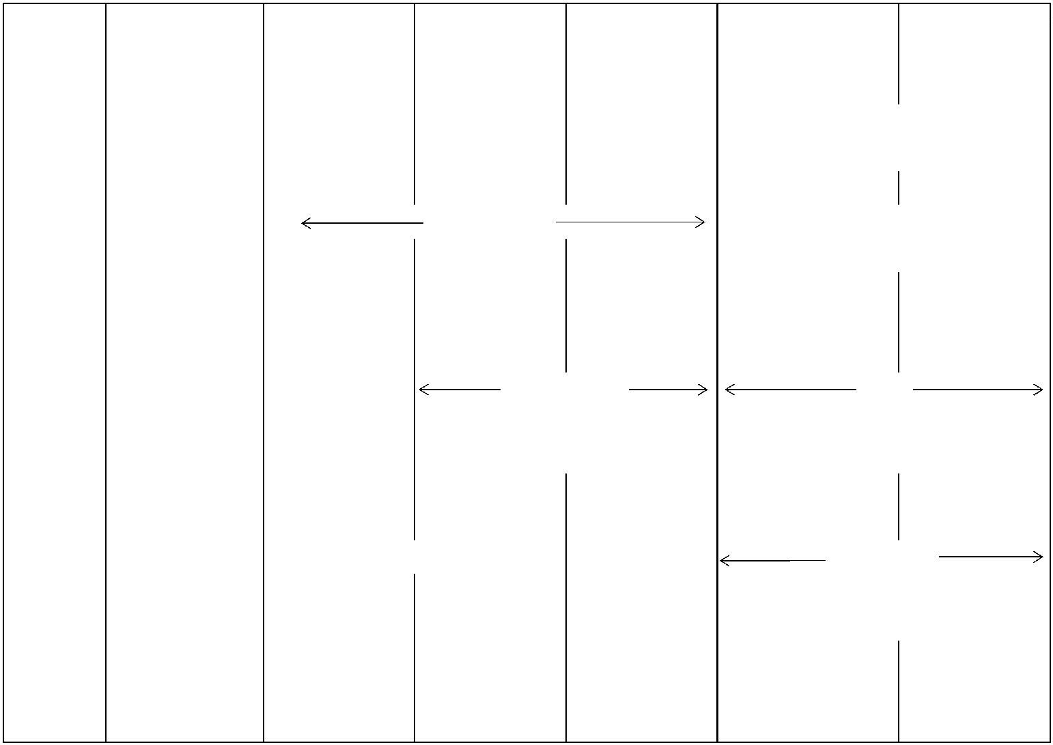
APPENDIX-A-II - 1/1
APPENDIX-A-II Materials Selection for Low Temperature Service
(for Guideline)
(ASTM) Temp. (°C)
-30 -45 -60 -75 -100 -115 -196
Cast A352 Gr. LCB/ A352 Gr. LC1 A352 Gr. LC2 A352 Gr. LC3 A352 Gr. LC4 A352 Gr. LC9
LCC A351 Gr. CF8/CF8M/CF3M/
CF3/CF8C
Forged A350 Gr. LF2 A350 Gr. LF3 A182 Gr. F304/304L/316/
316L/347, A522
Plate A516 Gr. 55 A203 Gr. A/B, A203 Gr. D/E A353
A537 (1) A553 Type I/II ⁽²⁾
A240 Type 304/304L/316/316L
Pipe A333 Gr. 1 A333 Gr. 3/7 A333 Gr. 3/9 A333 Gr. 8
A312 Gr. TP304/304L/316/316L,
A333 Gr. 8
(1) Temp. up to -106 °C
(2) Temp. up to -170 °C



APPENDIX-A-III - 1/1
APPENDIX-A-III Materials Class of Pump Parts
This table is an extract from a Table in API 610 standard. The corresponding table in API shall be referred to for details.
Material-Class and Material Abbreviations
Class I-1 I-2 S-1 S-3 S-4 S-5 S-6 Abbreviation- CI CI STL STL STL STL STL
Case
Abbrev.-Internal
CI BRZ CI NI-RESIST STL STL 12%CHR 12% CHR
Pressure Casing Cast Iron Cast Iron Carbon Steel Carbon Steel Carbon Steel Carbon Steel Carbon Steel
Inner case parts  (bowls, diffusers,  diaphragms) |  | Cast Iron Bronze Cast Iron Ni-Resist Cast Iron Carbon Steel 12% CHR
Impeller Cast Iron Bronze Cast Iron Ni-Resist Carbon Steel Carbon Steel 12% CHR
 | Case wear rings Cast Iron Bronze Cast Iron Ni-Resist Cast Iron 12% CHR  Hardened |  |  |  |  |  | 12% CHR  Hardened
 |  | Impeller wear  rings |  | Cast Iron Bronze Cast Iron Ni-Resist Cast Iron 12% CHR  Hardened |  |  |  | 12% CHR  Hardened
Shaft Carbon Steel Carbon Steel Carbon Steel Carbon Steel Carbon Steel AISI 4140 AISI 4140
Material-Class and Material Abbreviations
Class S-8 S-9 C-6 A-7 A-8 D-1 D-2
Abbreviation- STL STL 12% CHR AUS 316AUS DUPLEX SUPER
Case DUPLEX
SUPER
DUPLEX Abbrev.-Internal
316AUS MONEL 12% CHR AUS 316AUS DUPLEX
Pressure Casing Carbon Steel Carbon Steel 12% CHR AUS 316 AUS Duplex Super Duplex
Inner case parts  (bowls, diffusers,  diaphragms) |  | 316 AUS Monel 12% CHR AUS 316 AUS Duplex Super Duplex
Impeller 316 AUS Monel 12% CHR AUS 316 AUS Duplex Super Duplex
 | Case wear rings Hard Faced  316 AUS |  |  |  |  |  | Monel 12% CHR  Hardened |  |  |  | Hard Faced  AUS |  |  |  | Hard Faced  316 AUS |  |  |  | Hard Faced  Duplex |  |  |  | Hard Faced  Super Duplex
 |  | Impeller wear  rings |  | Hard Faced  316 AUS |  |  |  | Monel 12% CHR  Hardened |  |  |  | Hard Faced  AUS |  |  |  | Hard Faced  316 AUS |  |  |  | Hard Faced  Duplex |  |  |  | Hard Faced  Super Duplex
Shaft 316 AUS K-Monel 12% CHR AUS 316 AUS Duplex Super Duplex
The abbreviation above the diagonal line indicates the case material; the abbreviation below the diagonal line indicates
trim material.
Abbreviations are as follows;
BRZ = bronze, STL = steel, 12% CHR = 12% chrome, AUS= austenitic stainless steel, CI = cast iron
316 AUS = Type 316 austenitic stainless steel
Materials requirements by Licensers govern.

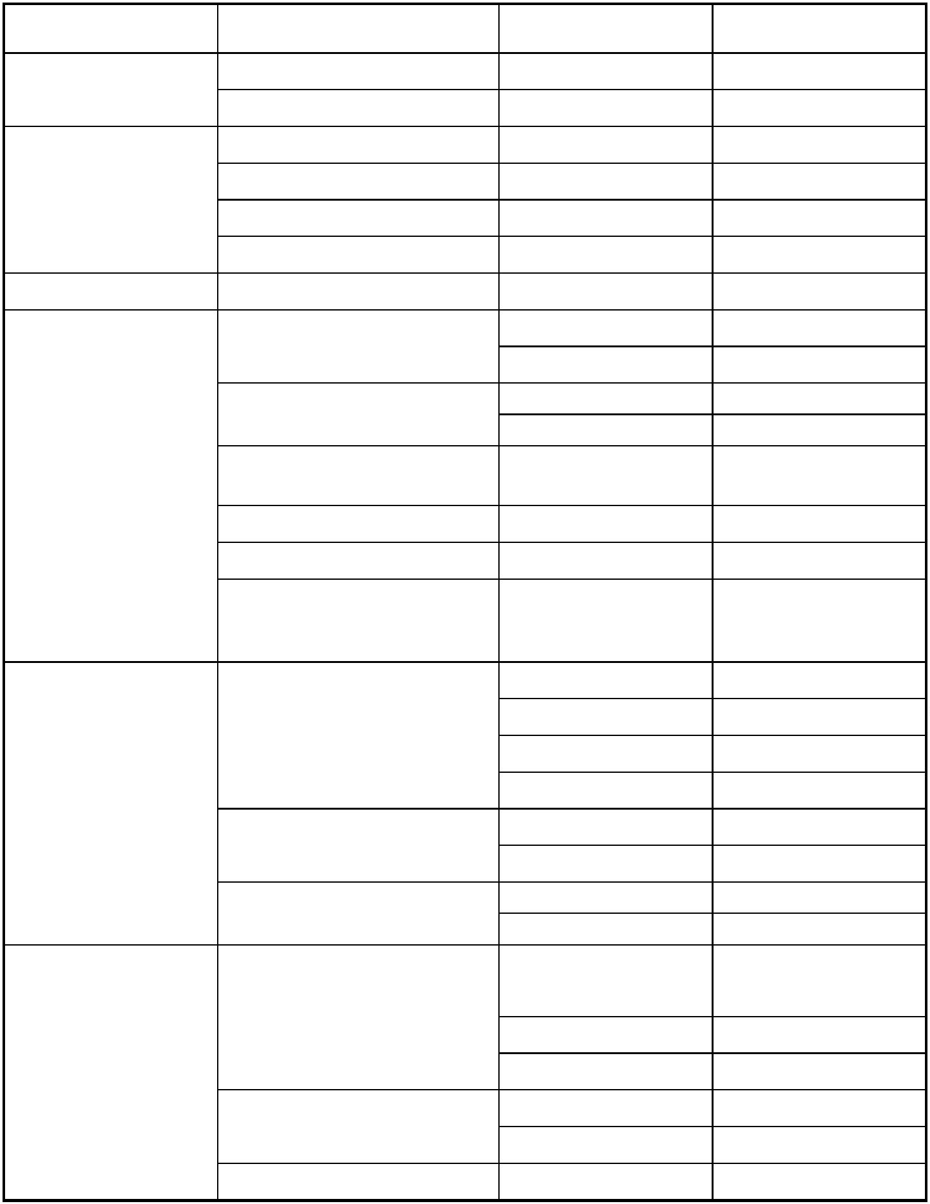
APPENDIX-A-IV - 1/1
APPENDIX-A-IV Typical Application of Material Codes
This table, which is an extract from a Table in API 610 Standard, shows typical application of the industry
material specification for each material class. The corresponding table in API shall be referred to for details.
Material Class Applications ASTM JIS
Cast Iron Pressure Castings A 278 Class 30 FC 300
General Castings A 48 Class 25/30 FC 250/300
Pressure Castings A 216 Gr. WCB SCPH 2
Wrought/Forgings A 266 Class 2 SFVC 2A
Carbon Steel Bar Stock : Pressure A 695 Gr. B40 S 25C
Bar Stock : General A 576 Gr. 1045 S 45C
AISI 4140 Steel Bar Stock A 434 Class BB SCM 440
Pressure Castings A 217 Gr. CA15 SCS 1
A 487 Gr. CA6NM SCS 6
Wrought/Forgings : A 182 Gr. F6a Class 1 SUS 410-A
Pressure A 182 Gr. F6NM SUS F6NM
 | 12 % Chrome Steel Wrought/Forgings :  General |  | A 473 Type 410 SUS F6NM
Bar Stock : Pressure A 479 Type 410 SUS 410 or 403
Bar Stock : General A 276 Type 410 SUS 410 or 403
 | Bar Stock/Forgings  Wear Parts |  | A 276 Type 420  A 473 Type 416  A 582 Type 416 |  | SUS 420J1 or 420J2
Pressure Castings A 351 Gr. CF3 SCS 13A
A 351 Gr. CF3M SCS 14A
 | Austenitic  Stainless Steel |  | General Castings |  | A 743 Gr. CF3 SCS 13A  A 743 Gr. CF3M SCS 14A
Wrought/Forgings A 182 Gr. F304L SUS F304L
A 182 Gr. F316L SUS F316L
Bar Stock A 479 Type 304L SUS F304L
 | Pressure Castings |  | A 479 Type 316L SUS F316L  A 351 Gr. CD4MCu
A 890 Gr. 1B
Duplex Stainless Steel A 890 Gr. 3 SCS 11
A 890 Gr. 4 SCS 10
Wrought/Forgings A 182 Gr. F51
A 479
Bar Stock A 276-S31803 SUS 329J3L

APPENDIX-B - 1/1
APPENDIX-B
DELETED.

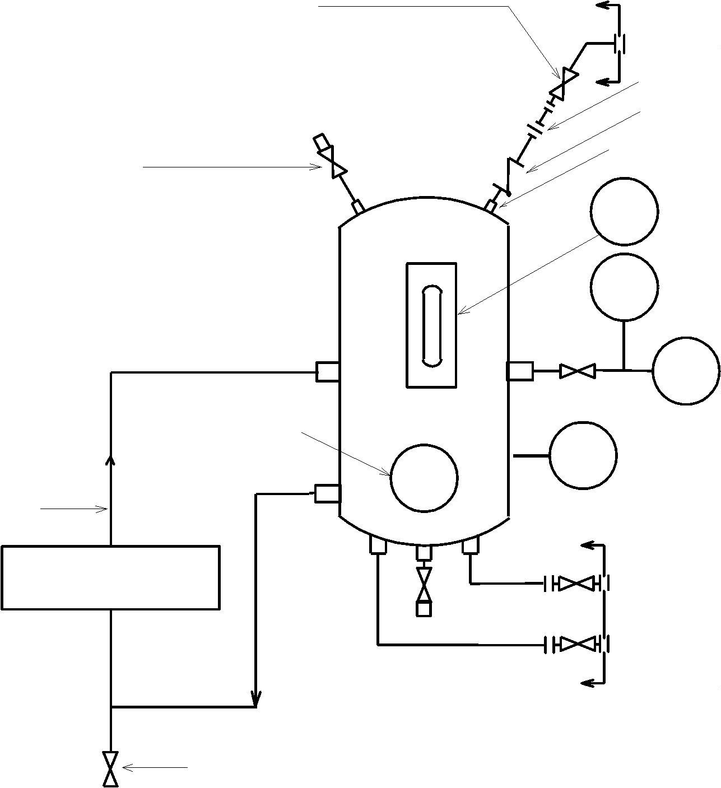
APPENDIX-C-I - 1/1
APPENDIX-C-I Detailed System of API Flushing Plan-52
(For Unpressurized Dual Mechanical Seals)
Normally open valve*
(Locked open type) By Vendor
To flare, when specified
Orifice
Non return valve*
3/4" Min
Fill 3/4" Min
LG
 | PSH |  | or LSH  **
PI
When specified
LSL TG
1/2" Min
By Vendor
Mechanical Seal
CWS
CWR
(If cooling is required)
Drain
* : When connected to flare line
** : A LSH shall be provided instead of a PSH for the pumps which handles liquid of low vapor pressure
(nearly atmospheric ressure) so that it will detect an abnormal leakage through the inboad seal.

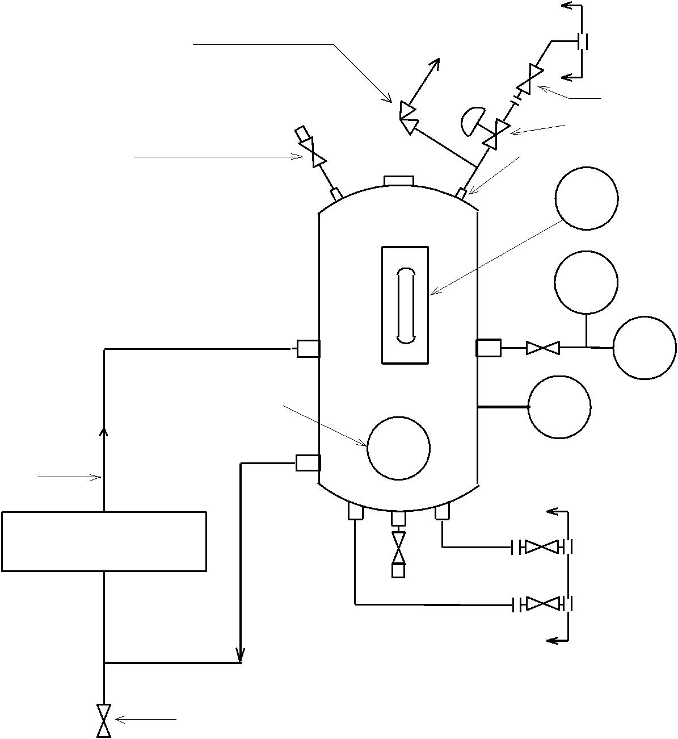
APPENDIX-C-II - 1/1
APPENDIX-C-II Detailed System of API Flushing Plan-53A53
(For Pressurized Dual Mechanical Seals)
By Vendor
Press relief valve **
External pressure source
To safe location
Normally open valve *
PCV**
Fill 3/4" min
3/4" Min
LG
PSL
PI
When specified
LSL
TG
1/2" Min
By Vendor
Mechanical Seal
CWS
CWR
(If cooling is required)
Drain
* : Refilling pump to be provided
when specified
** : If necessary

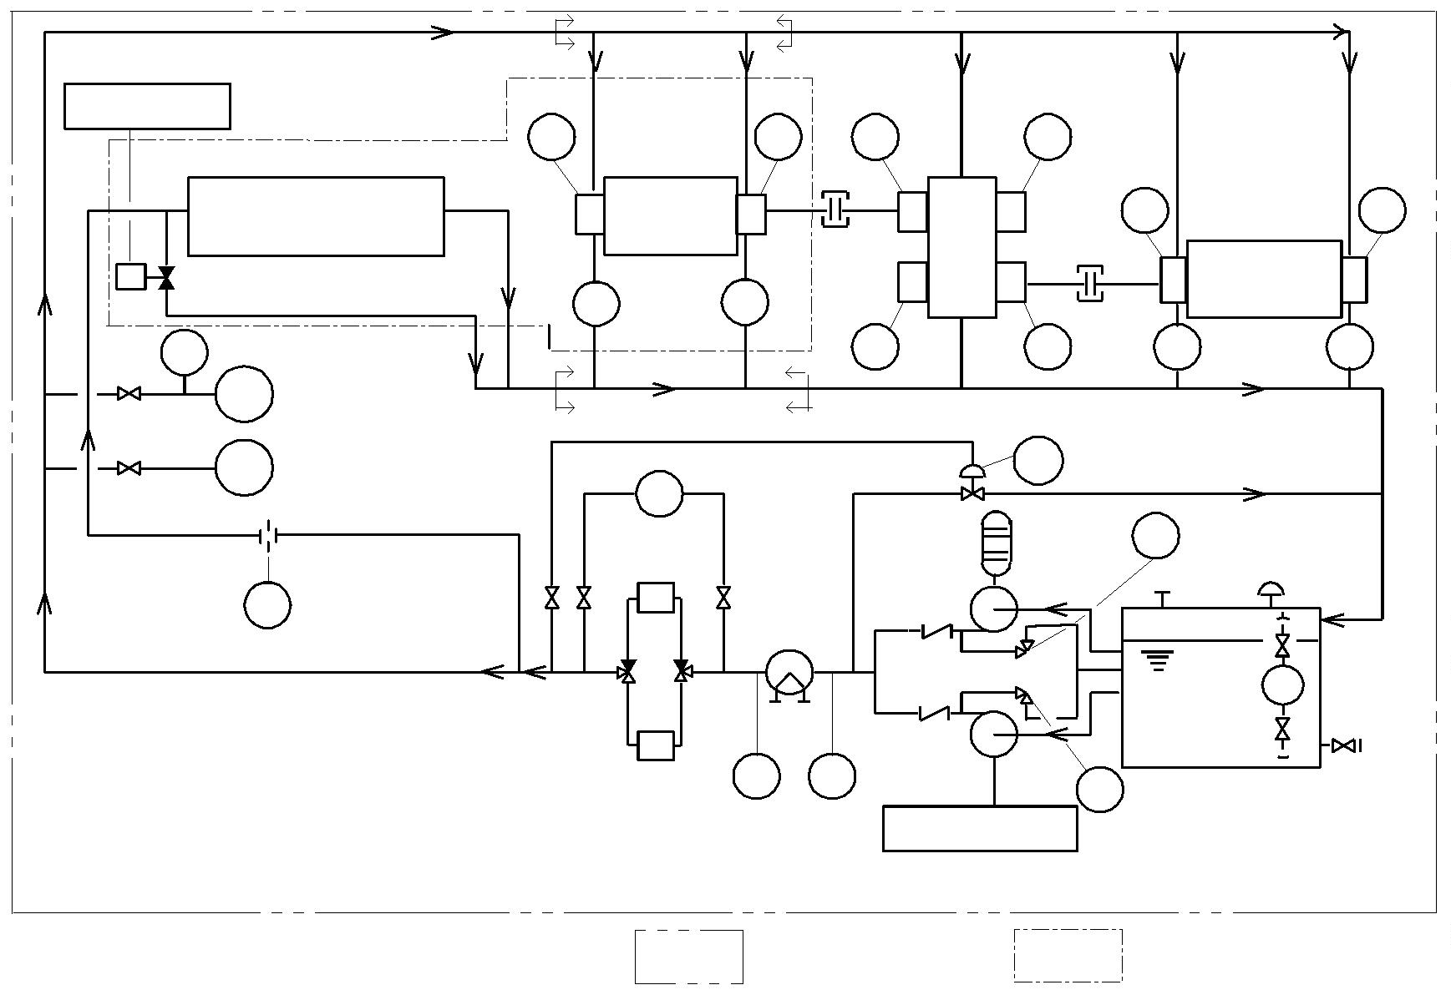
APPENDIX-D - 1/2
APPENDIX-D Typical Scheme of Pressurized Lube-Oil System (1/2)
(*4 )
Trip Signal
TG TG TG TG
by Turbine Vendor
 | S |  |  | Turbine Trip Valve  and/or Speed Governor  (When required) |  |  |  |  |  |  |  | Driver  SG SG |  |  |  | Gear |  | TG TG  Driven  Equipment
 |  | PG |  |  |  | (*2 )  PSL |  | (Alarm & AOP Start) |  | (*4 ) |  |  |  | TG TG  (*6 ) |  |  |  |  |  | SG SG
(*1 )
PSLL PCV
(Shut Down)
PdG
 | RO |  | (*1) |  | F |  | Aux. Oil  Pump |  | Motor  (*5 ) |  | SV
(*1 )
LG
 | (*7 )  F  TG TG |  | Main Oil  Pump |  | SV
Filters Cooler Reservoir (*3)
Shaft End Driven
 | Scope of Supply  for Pump Vendor |  | Scope of Supply  for Driver Vendor

APPENDIX-D - 2/2
APPENDIX-D Typical Scheme of Pressurized Lube-Oil System (2/2)
Notes :
*1: Pressure regulation method for lube-oil and for control-oil (marked with *1) shall be in accordance with Vendor’s
standard.
*2: When a local gauge board is provided, the gauge board shall mount a junction box for instrument-wiring, the gauges,
and indicators marked with (*2).
*3: When specified by Purchaser, an electric heater with a temperature gauge shall be provided.
*4: When the base plate of driver is separate from the pump base plate, the piping (marked with *4) shall be provided by
the driver vendor.
*5: A stop valve shall be provided at the aux. oil pump suction, if the oil pump is located below the oil level in the
reservoir.
*6: Provision of a sight glass for the gear box shall be as per Vendor’s standard.
*7: The TG may be located either on the piping or on the reservoir.


APPENDIX-E - 1/2
APPENDIX-E Material Specification of Auxiliary Piping for Pumps (1/2)
This table specifies piping materials for rotating equipment and its auxiliaries. The material grades in ( ) are given as typical
examples in accordance with ASTM Standards. Vendor may use alternate materials in accordance with other international
standards such as DIN and JIS, when it corresponds to the materials specified herein.
Components-Service Steam Cooling Water Lube/Seal Oil and Process Liquid
Pipe Carbon steel  (ASTM A53 Type S Gr. A or B)  or (ASTM A 106, Grade B)  or (ASTM A 524, Grade A or B)  or (API 5L, Grade A or B)  Minimum pipe wall thickness:  Sch. 160 for NPS 3/4 and smaller  Sch. 80 for NPS 1 - NPS 1-1/2  Sch. 40 for NPS 2 and larger |  |  |  |  | Carbon steel  (ASTM A53 Type F  or Type E Gr. A or B)  or (API 5L, Grade A or B)  Minimum pipe wall thickness:  The same as those for Steam |  | Stainless steel:  (ASTM A312), Type 304 or 316  Minimum pipe wall thickness:  Sch. 80S for NPS 1/2 - NPS 1,  Sch. 40S for NPS 1-1/2 - NPS 3,  Sch. 10S for NPS 4 and larger  or  Carbon steel for non-corrosive  liquid piping when specified  (Note-1):  Applicable materials and  minimum pipe wall thickness of  carbon steel are the same as those  for Steam.
Tubing Stainless steel (ASTM A269),  seamless Type 304 or 316  Minimum wall thickness: (Note-2) |  |  |  |  | Stainless steel  (ASTM A269), seamless Type  304 or 316 (Note-2) |  | Stainless steel  (ASTM A269), seamless Type 304  or 316  (Note-2)
Valves Carbon steel  (ASTM A 105, Class 800)  or (ASTM A 181, Class 800) |  |  |  |  | Carbon steel  (ASTM A 105, Class 800)  or (ASTM A 181, Class 800) |  | Carbon steel  (ASTM A 105, Class 800)  or (ASTM A 181, Class 800)
Pipe Fittings and Unions Forged carbon steel, Class 3000 Malleable cast iron  (ASTM A338) and (A 197  Class 150) |  |  |  |  |  |  | Stainless steel  (ASTM A 312), Type 304 or 316  or (ASTM A 182) F304
Fabricated joints for pipe  sizes of NPS 1 and less |  |  | Pressure below 0.5 MPa: Threaded,  socket welded or butt-welded |  | Threaded, socket welded or  butt-welded |  | Oil supply piping after filters up to  bearings: Butt-welded
 |  | Pressure above 0.5 MPa: Socket  welded or butt-welded |  |  |  |  | Except above: Socket welded or  butt-welded
Fabricated joints for pipe  sizes of NPS 1-1/2 and  larger |  |  | Butt-welded Butt-welded Butt-welded
Flanges Slip-on or weld-neck with Carbon  steel flange (ASTM A 105) |  |  |  |  | Slip-on or weld-neck with  Carbon steel flange (ASTM A  105) |  | Slip-on with Carbon steel flange  (ASTM A 105) or  Slip-on or weld-neck with Stainless  steel flange (ASTM A 182)
Gaskets Spiral wound with non-asbestos  filler, 304 or 316 windings and  external centering ring |  |  |  |  | Non-asbestos flat gaskets Non-asbestos flat gaskets for rating  Class 300 and lower  For rating Class 600 and higher,  spiral wound with non-asbestos  filler, 304 or 316 windings and  external centering ring
Flange bolting Alloy steel  (ASTM A 193, Grade B7),  or (ASTM A194, Grade 2H) |  |  |  |  | Carbon steel Alloy steel  (ASTM A 193, Grade B7),  or (ASTM A194, Grade 2H)
See Notes on the next page.

APPENDIX-E – 2/2
APPENDIX-E Material Specification of Auxiliary Piping Pumps (2/2)
Note-1: Carbon steel pipes are applicable for non-corrosive process liquid piping. Purchaser will specify if the liquid is
corrosive.
Note-2: Minimum tubing wall thickness shall be as follows: 1.0 mm for tubing size NPS 1/4 – NPS 3/8
1.5 mm for tubing size NPS 1/2
2.0 mm for tubing size NPS 3/4
2.6 mm for tubing size NPS 1
Note-3: List of the Material Standards specified in the table:
ASTM A 53 Specification for Pipe, Steel, Black and Hot-Dipped, Zinc-Coated Welded and Seamless
ASTM A 105 Specification for Carbon Steel Forgings for Piping Applications
ASTM A 106 Specification for Seamless Carbon Steel Pipe for High-Temperature Service
ASTM A 181 Specification for Carbon Steel Forgings for General Purpose Piping
ASTM A 182 Specification for Forged or Rolled Alloy-Steel Pipe Flanges, Forged Fittings, and Valves
and Parts for High-Temperature
ASTM A 192 Specification for Seamless Carbon Steel Boiler Tubes for High-Pressure Service
ASTM A 193 Specification for Alloy-Steel and Stainless Steel Bolting Materials for
High-Temperature Service
ASTM A 194 Specification for Carbon and Alloy Steel Nuts for Bolts for High-Pressure and
High-Temperature Service
ASTM A 269 Specification for Seamless and Welded Austenitic Stainless Steel Tubing for General Service
ASTM A 312 Specification for Seamless and Welded Austenitic Stainless Steel Pipes
ASTM A 338 Specification for Malleable Iron Flanges, Pipe Fittings, and Valve Parts for Railroad, Marine, and
Other Heavy Duty Service at Temperature up to 650 °F (345 °C)
ASTM A 524 Specification for Seamless Carbon Steel Pipe for Atmospheric and Lower Temperatures
API 5L Line Pipe Specifications

